AP European History

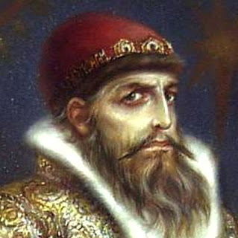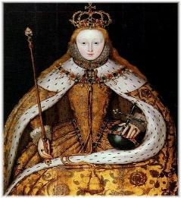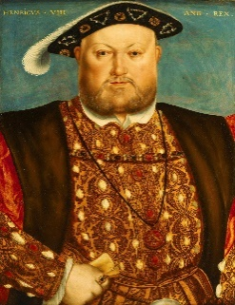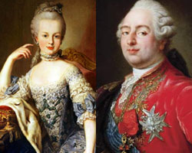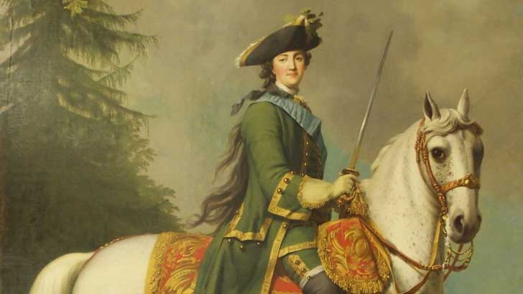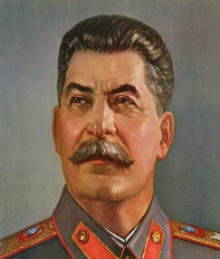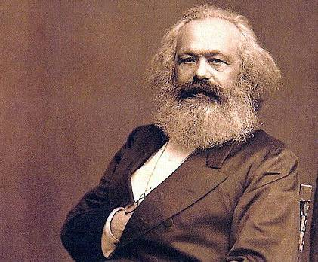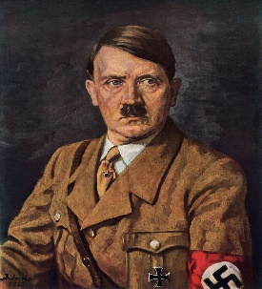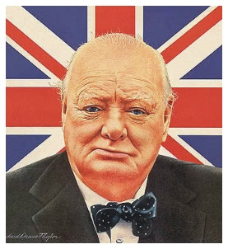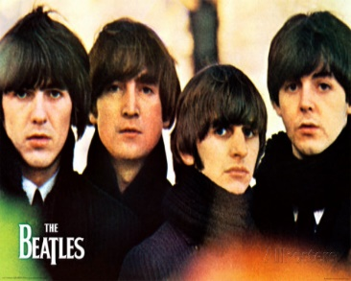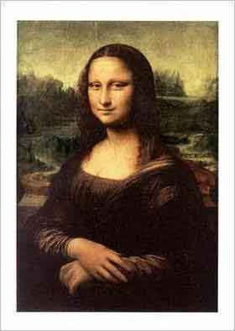

What’s It All About?

The Black Death Will Decimate the Continent, before

It’s Rebirth With The Renaissance.

A New World Will be Discovered.

The Church Will be Divided.

Wars of Religion Will Rage.

Societies Will Revolutionize.

New Nations Will Rise.

Industrialization and Technology Will Emerge.

Europe Will Colonize the Globe.

Two World Wars Will Rage.

The Iron Curtain Will Divide Europe.

The Cold War Will End, or did it…?

AP European History is a survey history course, which covers the history of Europe from the Renaissance to the Modern Age. We

Will be viewing European History through the lens of five historical

themes. We will also learning how to analyze primary and secondary

resources to support thesis essays.

❖A good score on the AP National Exam ***can replace***

***required credit in college typically Western***

***Civilization courses.***

***APEH is a GREAT companion course with***

***AP English Literature 12!***

APEH is an elective for 10th , 11th & **12th**

**APEH is a one Semester Course.**

**Optional** Summer Work Assignment.

**Check these videos out! ☺**

[***https://www.youtube.com/watch?v=wiaWv2jp9Zk***](https://www.youtube.com/watch?v=wiaWv2jp9Zk)

[***https://www.youtube.com/watch?v=Svj7e2cKtrw***](https://www.youtube.com/watch?v=Svj7e2cKtrw)

**APEH Information :**

⇨ APEH will fulfill a history elective credit.

⇨ APEH is a **semester** long class.

⇨If successful on the National AP Exam in May, you will

earn college credit and saving your parents on some college tuition. 😊

⇨ The AP Exam is typically paid for by the state of North Carolina.

⇨ Success on the AP European History Exam in May can earn you ***required college credit*** for Western Civilization courses typically required of college freshmen. It is the only AP history course that can replace college credit and will not be elective credit.

⇨ You will learn strategies & skills that will help you through your other AP classes during high school as well as prepare you for college classes.

⇨ We focus on differing study skills and notetaking skills (taking notes from reading assignments, class lectures & video assignments).

⇨ We will learn how to analyze primary and secondary sources.

⇨ We will cover European History from the Medieval Period to the modern era.

⇨ We will learn how to write the LEQ & DBQ essays, which will be on the National AP Exam.

⇨ Much APEH skills are highly transferable to other junior & senior course as well as future college courses. 😊

⇨ Click on the links to watch videos! 😊

Please DO NOT hesitate to email Ms. Pollock about ANY questions you might have about AP European History : [pollocr@gcsnc.com](mailto:pollocr@gcsnc.com)